Topic:- Chatbot Development Using NLP and AI for Customer Service
- Objective and analysis of the Project: -

Descriptive Analysis

Chatbot development for customer service leverages Natural Language Processing (NLP) and Artificial Intelligence (AI) to enhance interactions between businesses and their customers. A chatbot is an AI-driven program designed to simulate human-like conversations, addressing customer queries, resolving issues, and offering personalized assistance. Businesses integrate chatbots on websites, messaging apps, and other digital platforms to provide round-the-clock support.

Currently, chatbots are widely adopted in industries such as e-commerce, healthcare, banking, and travel. For instance, platforms like Amazon and Netflix use chatbots to recommend products or assist with account issues. Descriptive data indicates that over 70% of consumers prefer instant messaging for support, making chatbots a vital tool for businesses. Chatbots reduce response times, improve customer satisfaction, and significantly cut operational costs by automating repetitive tasks. The NLP component enables chatbots to understand user intent, process natural language, and provide relevant responses, ensuring a smooth conversational flow.

Diagnostic Analysis
While chatbot adoption has grown, its development presents challenges. One key issue is the difficulty in achieving accurate language understanding. Users often express queries in various ways, leading to ambiguity that NLP must resolve. For example, a user asking, "Can you help with my order?" could mean tracking, modifying, or canceling an order. Misinterpretations can result in poor customer experiences.

Another challenge lies in integrating chatbots with existing business systems, such as CRMs and databases, to access relevant customer information. Security concerns are also prevalent as chatbots handle sensitive data. To mitigate these issues, businesses are investing in advanced AI algorithms, training data, and robust security measures.

Trends in chatbot development include the use of sentiment analysis to gauge customer emotions, multilingual support for global businesses, and voice-enabled chatbots. Additionally, the incorporation of machine learning (ML) enables chatbots to improve over time by learning from interactions.

Predictive Analysis
The chatbot market is projected to grow exponentially, with advancements in NLP and AI driving this trend. Predictive models indicate that by 2030, chatbots will handle over 90% of customer interactions, drastically reducing the need for human intervention in routine tasks. AI models will become increasingly adept at understanding context, intent, and even cultural nuances, leading to more human-like conversations.

Predictive analytics suggests that businesses will shift towards hyper-personalization, where chatbots use customer data to anticipate needs and provide tailored recommendations. For example, a chatbot in e-commerce could predict when a customer might run out of a frequently purchased product and suggest reordering before stock runs out. Furthermore, chatbots are expected to transition from rule-based systems to more dynamic, conversational AI, making interactions fluid and intuitive.

Voice-based chatbots are also forecasted to gain traction, aligning with the growing popularity of smart home devices. Additionally, the integration of augmented reality (AR) with chatbots could create immersive customer experiences, such as virtual shopping assistants guiding users through products visually.

Prescriptive Analysis
To maximize the potential of chatbots in customer service, businesses should adopt the following strategies:

  - Define Clear Objectives: Identify the specific tasks the chatbot will handle, such as resolving FAQs, managing appointments, or processing payments.
  - Invest in Robust NLP Models: Utilize advanced NLP frameworks like OpenAI GPT or Google BERT to enhance language understanding and generate accurate responses.
  - Prioritize User Experience (UX): Design intuitive conversational flows and provide fallback mechanisms to connect users with human agents for complex queries.
  - Ensure Data Security: Implement encryption and compliance with regulations like GDPR to protect customer data.
  - Leverage Continuous Learning: Use machine learning to analyze interaction data and improve chatbot performance over time.
  - Test and Optimize: Conduct rigorous testing to identify and fix bugs, ensuring the chatbot operates seamlessly across different platforms.
  - Provide Multilingual and Omnichannel Support: Expand accessibility by supporting multiple languages and integrating chatbots across various channels such as social media, email, and voice assistants.

By implementing these strategies, businesses can ensure effective chatbot deployment, improve customer satisfaction, and gain a competitive edge in the digital marketplace.

- Graphical Abstract: -
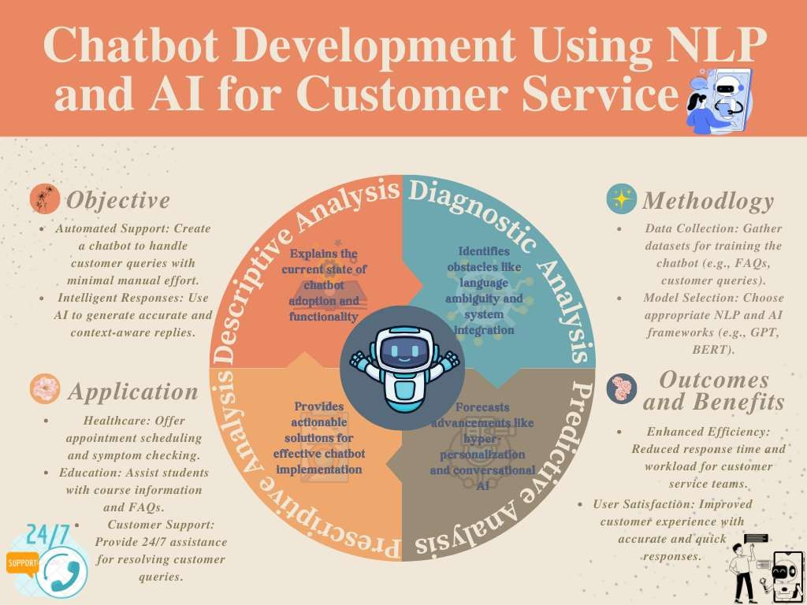

- Types of agents: -

Simple Reflex Agent
Description: Responds based on predefined rules and does not maintain memory of past interactions.
Strengths: Fast response time, efficient for structured FAQs and simple commands. Limitations: Cannot handle context-aware conversations or complex user inputs.
Use Case: Suitable for handling basic queries such as store hours, return policies, and general FAQs.

Goal-Based Agent
Description: Acts to achieve specific goals using reasoning and planning.
Strengths: Can make decisions that work towards a long-term goal rather than just reacting. Limitations: May require complex algorithms and more computational power.
Use Case: Ideal for customer service chatbots designed to guide users towards making purchases, troubleshooting issues, or completing processes.

Utility-Based Agent
Description: Evaluates possible actions based on a utility function to maximize benefits. Strengths: Makes optimal decisions to enhance customer satisfaction and efficiency.
Limitations: Requires a well-defined utility function and real-time evaluation of options.
Use Case: Best suited for chatbots focused on personalized recommendations, such as suggesting products or services based on user preferences.

Learning Agent
Description: Continuously improves performance by learning from user interactions. Strengths: Adapts over time, providing more accurate and personalized responses.
Limitations: Requires extensive training data and ongoing refinement.
Use Case: Suitable for AI-driven customer support bots that evolve based on historical conversations and feedback.

Model-Based Agent
Description: Maintains an internal model of the world to track the state of interactions. Strengths: Can manage context and multi-turn conversations.
Limitations: Requires a well-defined model and additional processing power.
Use Case: Suitable for chatbots that handle bookings, order tracking, and structured customer support interactions.

- PEAS Representation for Chatbot Agents
PEAS (Performance measure, Environment, Actuators, Sensors) defines the structure of an intelligent agent. Below is the PEAS representation for each chatbot agent type:

Simple Reflex Agent
  - Performance Measure: Quick and accurate responses to predefined queries.
  - Environment: User queries based on structured FAQs.
  - Actuators: Text-based responses using rule-based templates.
  - Sensors: Keyword detection and rule-matching algorithms.

Goal-Based Agent
  - Performance Measure: Successfully guides users to complete goals (e.g., booking, troubleshooting).
  - Environment: User queries requiring step-by-step resolution.
  - Actuators: Decision-making algorithms that generate responses based on goal progression.
  - Sensors: Intent recognition and reasoning models detecting user objectives.

Utility-Based Agent
  - Performance Measure: Maximizes customer satisfaction and efficiency of responses.
  - Environment: Dynamic conversations involving recommendations and decision-making.
  - Actuators: Utility-based ranking system for selecting optimal responses.
  - Sensors: Sentiment analysis, customer preference tracking, and historical data.

Learning Agent
  - Performance Measure: Continuous improvement in accuracy and relevance of responses.
  - Environment: Real-world customer interactions evolving over time.
  - Actuators: Adaptive response system based on machine learning insights.
  - Sensors: Data collection from user feedback, interactions, and training models.

Model-Based Agent
  - Performance Measure: Maintains conversation context, providing coherent responses.
  - Environment: Customer service interactions with multi-turn dialogues.
  - Actuators: Context-aware responses through an internal knowledge model.
  - Sensors: NLP engine tracking user history and state transitions.

Summary of PEAS Representation for Each Agent
The following table summarizes the PEAS (Performance measure, Environment, Actuators, Sensors) representation for each chatbot agent:

Agent Type | Performance | Environment | Actuators | Sensors
Simple Reflex Agent | Quick and accurate predefined responses | User queries based on structured FAQs | Rule-based text responses | Keyword detection, rule- matching algorithms
Model- Based Agent | Maintains conversation context | Customer service with multi-turn dialogues | Context-aware responses from an internal model | NLP engine tracking user history and state transitions
Goal- Based Agent | Guides users to achieve specific goals | Queries requiring structured goal completion | Decision- making algorithms | Intent recognition, reasoning models
Utility- Based Agent | Maximizes customer satisfaction and efficiency | Dynamic conversations with recommendations | Utility-based ranking system | Sentiment analysis, customer preference tracking
Learning Agent | Continuously improves response accuracy | Real-world evolving customer interactions | Adaptive responses based on machine learning | User feedback, interaction data, training models

    - BFS Tree
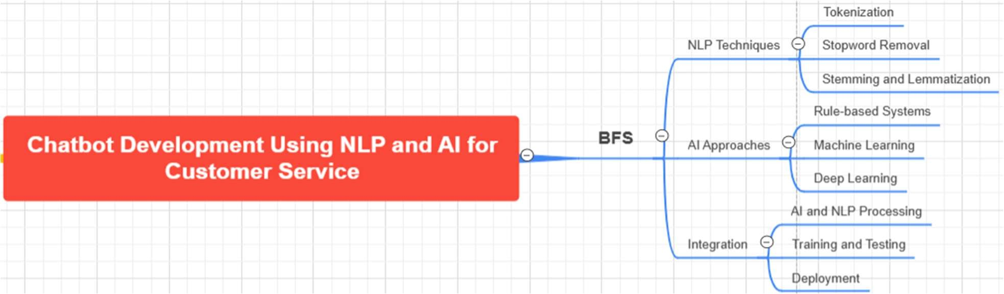

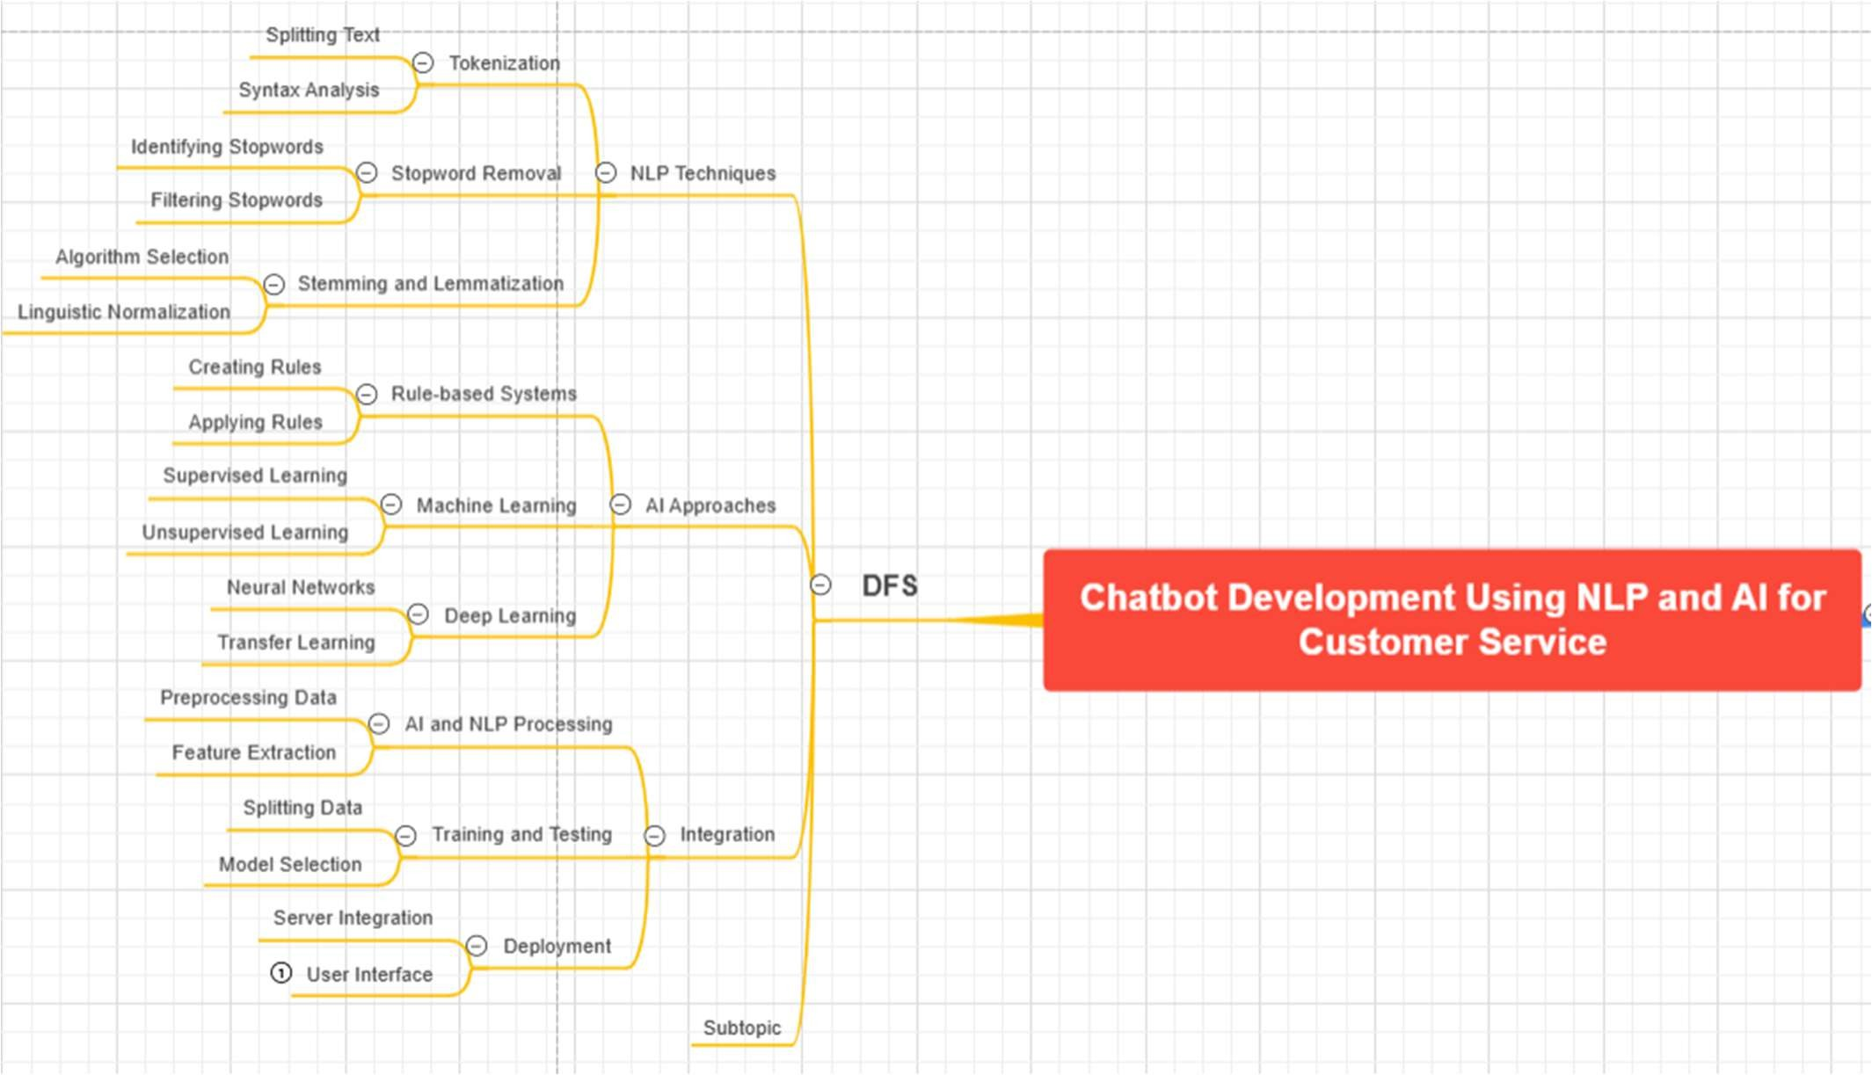
    - DFS Tree

Backtracking Search for CSP

Application to Chatbot:
To match user-reported symptoms to possible diseases, while satisfying constraints like age, gender, and severity.

Implementation Idea:
- Variables: Symptoms (e.g., fever, cough, headache)
- Domains: Possible values (present, absent)
- Constraints:
  - Minimum number of symptoms needed for diagnosis
  - Symptoms must align with age/gender-specific conditions
  - No conflict with known medical history

Technique Used: Backtracking Search
- Tries to assign values (symptoms) to variables one by one.
- If constraints are violated, it backtracks and tries another value.
- Continues until a consistent and complete assignment (diagnosis) is found.

- Model Used: - Multinomial Naive Bayes
- Excellent for Text Classification: Multinomial Naive Bayes is built for categorizing text based on word frequencies. Since our chatbot's goal is to classify symptoms into possible diseases, MNB naturally aligns with the task. It handled the symptom text inputs smoothly and predicted relevant illnesses accurately.
- Simple Yet Powerful: The model is lightweight and easy to train compared to deep learning models. For a first-level medical screening chatbot, MNB provided quick, efficient, and explainable predictions without needing heavy computational resources.
- Works Well with Small Datasets: Unlike deep learning models, which require vast amounts of data, MNB performed strongly even on a moderate-sized symptom dataset. This is important because curated medical symptom data is limited.
- Fast Training and Prediction: Speed is critical for a chatbot that needs to respond in real-time. MNB’s simplicity allowed it to predict the probable illness within milliseconds, making the user experience smooth and responsive.
- Handles Noisy Text Well: Patient input can be messy and unstructured ("cough a lot", "head hurts badly"). MNB’s probabilistic nature made it robust to minor typos, synonyms, and variations in how patients describe their symptoms.
- Good Baseline for Expansion: The chatbot architecture built on MNB is easy to scale. In the future, we can integrate more complex models (like BERT or LSTM) on top of it if needed, but MNB gives a very strong initial performance.

Challenges Faced (But Handled)
- Assumption of Feature Independence: MNB assumes that the features (words) are independent, which isn't always true in real symptom descriptions (e.g., "fever" and "cough" are often related). However, with proper preprocessing (like n-grams), the model still performed effectively.
- Limited to Pre-Defined Categories: The model can only predict illnesses it has been trained on. New or rare diseases would require retraining with updated data. This was mitigated by designing a fallback intent where unknown symptoms prompt the user to seek human medical advice.
Benifites of using Multinomial Naive Bayes
Criteria | Multinomial Naive Bayes Performance
Speed | Excellent
Accuracy | High (for basic symptom sets)
Data Requirements | Low
Handling Nonlinearity | Moderate (needs feature tuning)
Scalability | Good
Explainability | Very High

Summary
In short, Multinomial Naive Bayes succeeded not because it was the most complex model available, but because it matched the nature of the problem perfectly: fast, reliable, interpretable symptom classification.
Its strengths in handling short medical texts, small datasets, and providing real-time predictions made it an ideal choice for developing a medical chatbot that checks symptoms, gives descriptions, and recommends precautions.
